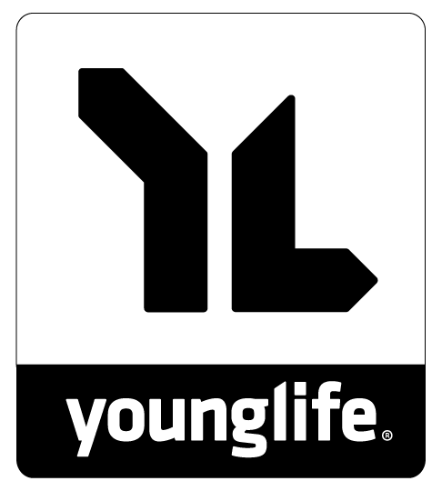
7th Annual
Truffle Shuffle
5K Walk/Run & 10K Run

April 25, 2020 • 9 a.m. • Downtown Baker City at First & Washington Streets

5k & 10k Run Start time is 9 a.m. at First and Washington streets. Both the 5K and 10K routes include an uphill section on Indiana Avenue, because this chocolate is worth the work! Please stick around for prizes at the end of the race!

Registration Register online at http://truffleshuffle.itsyourrace.com or drop off this registration form and payment at Peterson's Gallery, 1925 Main St., Baker City, OR 98714. Race-day registration is available at 8 a.m. at the race location.

Fees Entry fee is $30 with a shirt, or $20 without a shirt, and each participant will receive a chocolate medallion at the finish line. All the chocolate is handmade by chocolatier Alyssa Peterson of Peterson’s Chocolates. Pre-registration due by April 1st (in order to receive a shirt). Shirts not included for registrants after April 1st. Please make checks payable to Baker City Young Life.
**Kids Race for ages 12 and younger: $10 entry (max $30 per family plus parent fees if participating) – Guardians can sign up children with the form below. Please sign the waiver. No t-shirt for kids, but there will be medals and prizes!
All proceeds benefit Baker City Young Life.
PLEASE READ CAREFULLY & SIGN

I hereby acknowledge that participation in the 2019 Truffle Shuffle competition carries with it potential hazards. I am aware that traffic and pedestrians will be using the same roadways as I am during the race. An accident could cause injury or death. In consideration of the acceptance of this entry, I, the undersigned participant, intending to be legally bound, do hereby for myself, my heirs, executors, administrators or assigns, waive, release, and forever discharge any and all rights and claims I may have against Baker City Young Life and the City of Baker City, and any and all sponsors, promoters and/or their officers, agents, representatives, or assigns, of all liabilities, claims, actions, damages, costs or injuries that may be suffered by me before, during, or after the event. I understand that this waiver includes any claims based on negligence, actions or inaction of any of the above parties. I recognize the difficulties of this event and attest that I am sufficiently physically fit to compete safely in this fun run and that I have not been advised otherwise by a qualified medical person. I agree to allow my photo, video, film likeness and name to be used for promotion or legitimate purpose by this race, event producer and/or sponsors. I have read and understand the rules and regulations of the Truffle Shuffle event.

Signature ______________________________________________________________________________ Date:_______________________________________
(Guardian signature required for those under 18)

Name: __________________________________________________________________________________ ( ) Male ( ) Female
Age (on race day): ________________________ City, State: _______________________________________________________
Phone number: ____________________________________ Email address: __________________________________________
Race (please circle one) 5k walk/run 10k run Kids Run
Shirt size (please circle one) Unisex: Small / Medium / Large / X-Large / XX-Large
Chocolate medallion flavor (please circle one) Milk chocolate Dark chocolate White chocolate
For questions, please contact: truffleshufflebc@gmail.com

